**Exp:3**

**Aim:Create a HTML page with different types of frames floating frame navigation frame and mixed frames.**

**Source code:**

**Iframe:**

html>

<head>

<title>contact</title>

</head>

<body>

<iframe src="ph.html" height="300" width="300">

</iframe>

</body>

</html>

**Output:**

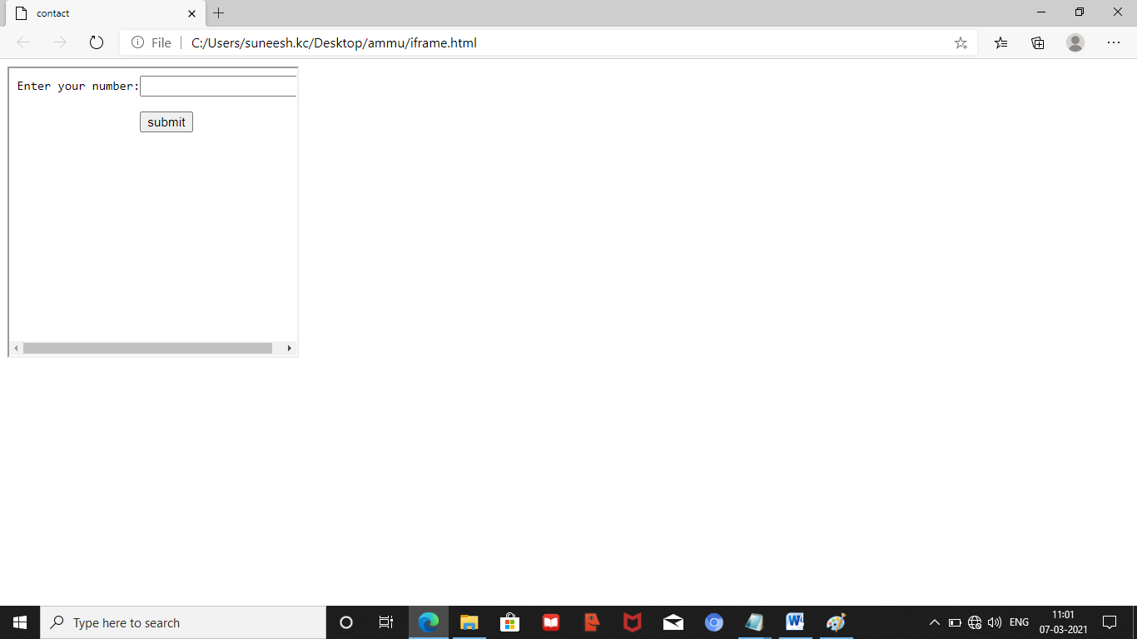

**Mixed frame**

<html>

<head>

<title>mframe</title>

</head>

<frameset cols="60,40">

<frame src="link.html">

<frameset rows="40,60">

<frame src="form.html">

<frame src="ph.html">

</frameset>

</frameset>

</html>

**Output:**

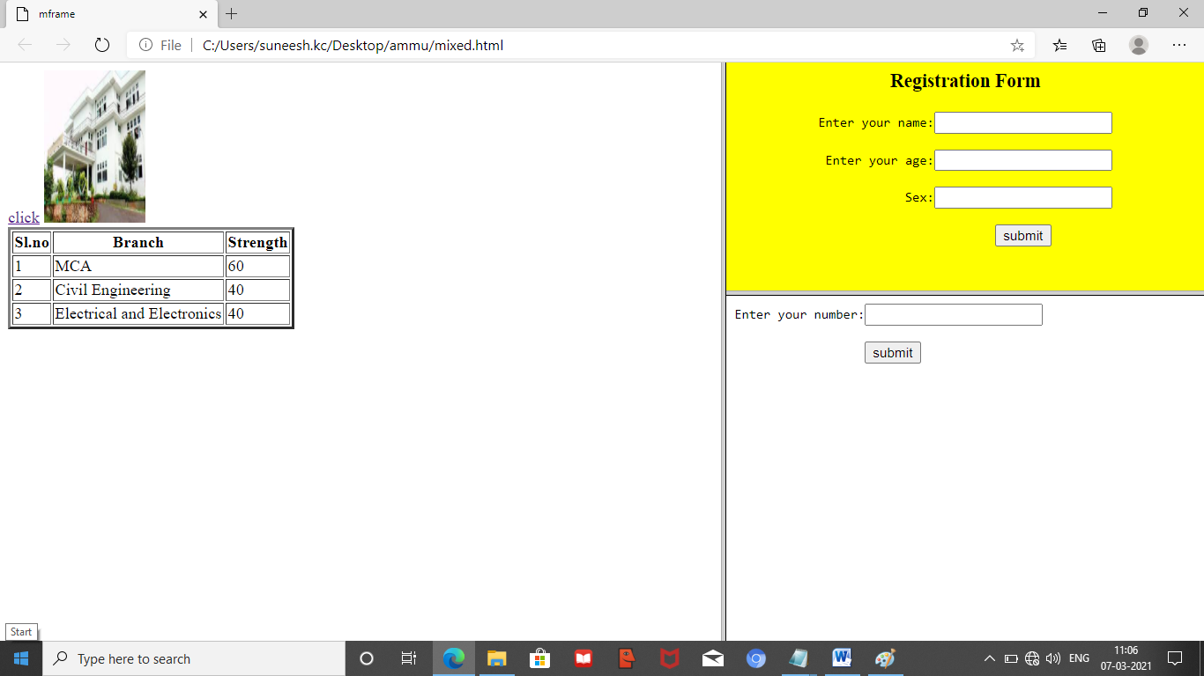

**Navigation frame:**

**main.html**

<html>

<head>

<title> frame</title>

</head>

<body bgcolor="pink">

<h2>Select the option</h2>

<a href="sample.html" target="right_frame">framea</a><br>

<a href="form.html" target="right_frame">frameb</a><br>

</body>

</html>

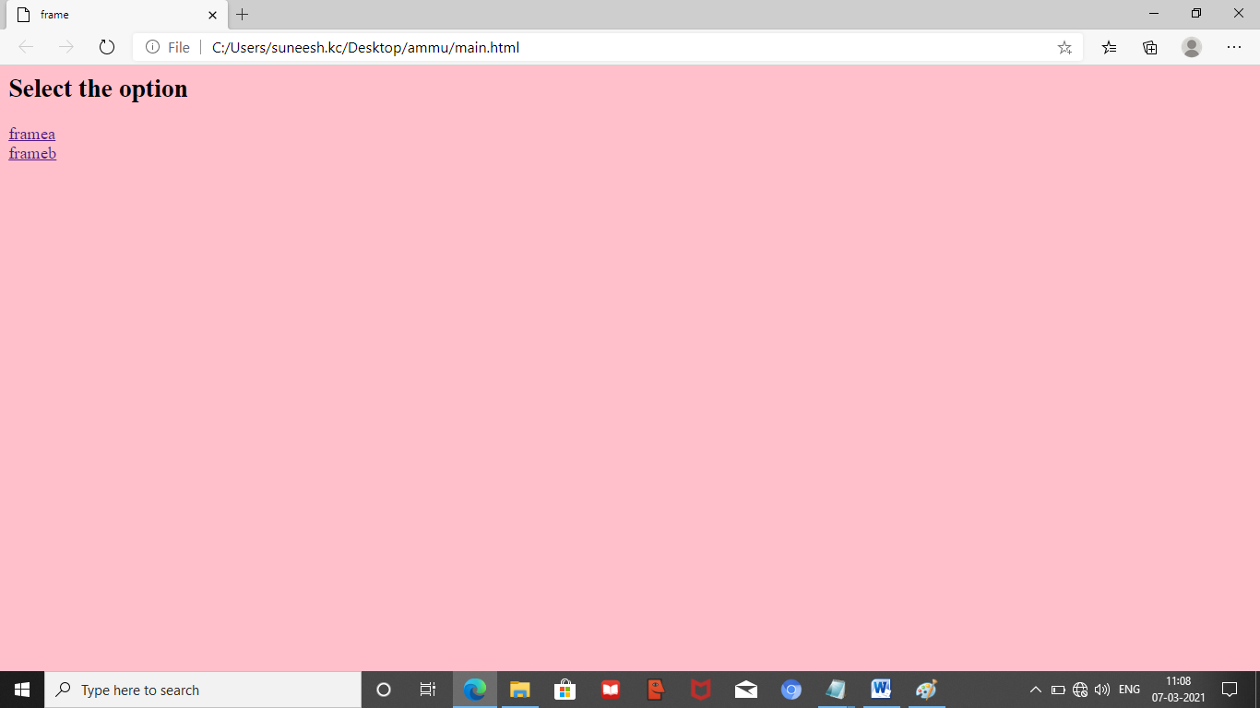

<html>

<head>

<title>targeting frame</title>

</head>

<frameset cols="200,*">

<frame src="main.html" name="left_frame">

<frame name="right_frame">

</frameset>

</html>

